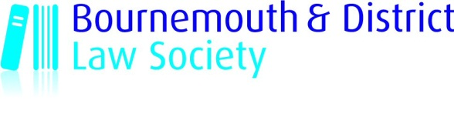

WEBINAR – MANAGING THE CONVEYANCING
RISKS THAT PI INSURERS DON’T LIKE!
TUESDAY 18 & 25 JANUARY 2022 – 11.30 – 13:00

Webinar details: The platform is Zoom and can be viewed on a mobile, tablet, laptop or PC. The link to join will be emailed
to you nearer the time. It would be helpful to download Zoom on to your device beforehand - the app is Zoom Cloud Meetings. Please note that it may not be possible to access your video and microphone if you are remote accessing your office computer - you may want to forward the link.

Cost: £95 – Member and Associate Members of BDLS/Trainee Solicitor
£145 – Non-Member of BDLS 3 hours CPD
This course is being presented by Lorraine Richardson as two 1½ hour webinars, one week apart.

2021 proved to be one of the most brutal Professional Indemnity insurance renewal rounds for conveyancers – with some firms going under as a result of not being able to secure insurance. It is well known that conveyancing is fraught with risk – but the indemnity insurers have identified some key areas of concern. This 3-hour course will look at those areas and will help practitioners to consider how they might mitigate those risks.

The course will cover:
- Estate management charges
- Escalating ground rents
- New builds – acting on multiple plots
- Buyer funded builds
- Cyber threats
Lorraine Richardson (M.A. Cantab) is a conveyancing expert, solicitor, and legal trainer.

Whilst in partnership in practice, she ran a branch office and was the COLP for her firm. Lorraine is now freelance and has set up her own company, Adapt Law Limited. In addition to locum work, she writes and delivers training for a variety of organisations including law firms, universities, and professional bodies.

Lorraine works with the Legal Training Team to deliver bespoke courses for in house firms and in addition to conveyancing, she also specialises in compliance, legal skills and professional conduct.

Lorraine is a main contributor for the monthly update publication for practitioners, ‘The Practical Lawyer’ and is delighted that her new book, ‘A Practical Guide to Document Signing and Electronic Signatures for Conveyancers’, has been published by Law Brief Publishing.
_______________________________________________________________________________________________

BOOKING FORM
WEBINAR – MANAGING THE CONVEYANCING RISKS THAT PI INSURERS DON’T LIKE!
TUESDAY 18 and 25 JANUARY 2022 – 11:30 – 13.00
Please complete and return this slip with your payment by Tuesday 11 January 2022
Bournemouth and District Law Society, Borough Chambers, Fir Vale Road, Bournemouth BH1 2JJ – DX 7616 Bournemouth – Tel: 01202 587551 email: office@bournemouthlaw.com

No* | Membership Type | Cost
 | Solicitor Member | £95
 | Associate Member | £95
 | Trainee Solicitor | £95
 | Non-Member | £145
Cheque/BACS* payment made for |  | £
*Please indicate

Cheques: payable to “Bournemouth & District Law Society”

BACS: Account Name: Bournemouth & District Law Society Account No: 56568851 Sort Code: 56-00-35.
Important: Please quote reference ”906/initials or surname of delegate”

Name of Delegate(s)
Name of Firm
Email

